**ANALYSIS OF IMPACT OF HUMAN ACTIVITIES ON THE RIPARIAN ZONE OF ONA RIVER BASIN, IBADAN, OYO STATE.**

**Dr C.N Egbinola and Temitope Bamidele**

**Department of Geography**

**University of Ibadan, Ibadan, Oyo State, Nigeria**

**Corresponding E-mail: Christy_emu@yahoo.com**

**ABSTRACT**

Human activities such as farming, urban development, and expansion of paved surfaces are the major threats to riparian zones especially in the developing countries; little attention is given to the numerous ecosystem services offered by the riparian zone in these countries.

The riparian zone of the Ona drainage basin in Ibadan is no exception, as years of Human encroachment and degradation of the zone has left it begging for attention in terms of restoration and conservation. Geographic Information System (GIS) and Remote sensing techniques were employed in this study to analyze the spatial and temporal changes in the landscape of the riparian zone and to also determine the contribution of specific human activities to these changes. The riparian zone in the Ona drainage basin was delineated by overlaying, buffered stream order of the basin on the slope of the basin generated from its digital elevation model, the result of this was also overlaid on the land use/ land cover images of three time period of the basin for analyze of spatial temporal changes and also to examine the extent of human impact.

Results from the study indicated that farming and open surfaces are the human activities that have largely contributed to changes within the riparian zone.

Keywords: GIS, Riparian zone, Basin

**INTRODUCTION**

A riparian zone is the interface between land and water bodies, including streams, rivers, lakes and estuarine marine shores. Riparian zones can therefore be considered as a transitional belt between terrestrial and aquatic ecosystems and are distinguished by gradients in biophysical conditions, ecological processes and biota (National Research Council, U.S, 2002). Land-use and land-cover along river corridors are by far the most dynamics of all ecosystems in both natural and altered landscapes. The riparian landscapes are made up of patches of distinct vegetation types, wetlands and other land uses, such as agricultural crops and urban settlements. A river’s corridor vegetation plays a significant role in soil erosion, channel stability, wildlife and fish habitat, and water quality (Ahmad and Nobukazu, 2004).

Riparian vegetation has many critical functions; it provides resistance to flowing water as well as to runoff during floods. The vegetation provides protective cover which helps to absorb the forces exerted by flowing water (Watson and Basher, 2006). Riparian plant canopies intercept, store and evaporate a portion of precipitation and have an important role in influencing stream temperature and the health of aquatic species (National Research Council, U.S., 2002). Vegetation in riparian areas also have important roles in regulating the upstream-downstream movement of matter and energy by filtering or stopping the movement of sediments, water and nutrients. Specifically, riparian vegetation has an important filtering role for dissolved nitrogen, phosphorous, and toxins moving along the slope discharge ( Apan *et. al.,* 2002).

In many areas, riparian vegetation is spectrally inimitable because of its more persistent greenness when compared to upland areas and other land-cover classes (Woodward *et. al*., 2018). Riparian vegetation acts as habitat corridors for the flow of species, energy, nutrients and promotes regional biological diversity.

At local and regional scales, riparian corridors are delineated in numerous ways, as their definition is usually dependent on research approach or agency targets. Generally, they are the transition between terrestrial and freshwater ecosystems and include components of topography, vegetation, and soils. Riparian corridors are dynamic regions with complex heterogenic landscapes formed by frequent disturbances, and therefore, are challenging to delineate and map across large spatial scales. Even fixed buffers along streams have been broadly employed in delineating riparian corridors. The total potential maximum extent of riparian corridors can be captured based on geomorphology, and within this area, temporal fluctuations in riparian corridor vegetation can be evaluated with spectral imagery.

One of the most effective techniques in riparian buffer assessment studies is based on using Geographic Information Systems (GIS), because traditional studies generally depends on field-based surveys, which are time intensive and limit the spatial amount of area that can be assessed. As a result, GIS and remote sensing techniques were found to be a convenient way to determine critical areas near water bodies with regards to quality (Emre, 2013).

**Table 1. General recommended widths of buffer zones**.

|  |  |  |
| --- | --- | --- |
| Riparian function | Description of Buffer Type | Recommended Width |
| Water Quality Protection | For protecting the water quality of water bodies (especially regarding nitrogen and phosphorus loading), the average minimum and maximum recommended riparian widths are about 15m and 100m. | 15 – 100m |
| channel banks and shorelines protection | To protect channel banks and shorelines, the suggested minimum and maximum widths average about 15m and 25m | 15 – 25m |
| Flood Hazard reduction | To provide flood control and to support aquatic resources in adjoining water bodies, most of the recommended riparian widths fall between about 15m and 60m | 15 – 60m |
| Riparian Microclimate  Control | To sustain natural riparian microclimates, a functional width of about 70m-130m is recommended. | 70 – 130m |
| Riparian Wildlife Support | Maintaining the intrinsic ecological functions of riparian areas, such as their support of riparian wildlife, require the broadest areas | 40 – 160m |

(Source: Joshua *et. al.*, 2006)

Riparian areas represent a relatively small percentage of the total land cover of the Nigeria landmass covering about 5,254 km² (FORMECU 1998) and are intensively disturbed, they are often considered to be at-risk due to the effects of urbanization, agriculture, and modified water flow regime. Anthropogenic activities, such as urbanization, agricultural, industrial, transportation and communication, have altered or degraded many riparian environment. Degradation of riparian zones is a result of complex interrelated responses from geomorphic, hydrologic and biotic processes to climate change and natural and anthropogenic disturbances (Chambers and Miller, 2004). The disturbances can alter the hydrological or sediment regime of the river/stream system and produce changes in the physical properties of riparian ecosystems such as stream channel characteristics, and surface and ground water interactions.

Human activities such as agriculture, harvesting of riparian flora and hunting of riparian fauna, grazing and industrial discharges have a great impact on riparian ecosystems. Direct discharge of untreated waste from industries, domestic and urban sources into fresh water bodies contribute to various forms of pollution, eutrophication, suspended solids, sedimentation and pesticide residues leached from soils and agricultural plantations (Odadal *et. al.*, 2003). Human impact such as dams, deforestation and water use practices pose serious threats to water availability to downstream populations (USAID, 2008). Degradation of riparian zones not only affects the riparian area but also the surface and ground water resources, the aquatic fauna and flora, and the terrestrial ecosystem. The riparian zone of the Ona basin in Ibadan has been degraded over time due to the impact of human activities like urbanization, farming, land and vegetation clearing among other.

In view of the foregoing, this study focuses on using GIS Hydrological analysis and remote sensing techniques to identify the major human activity that affect the riparian zone for proper restoration and conservation practice. The following objectives were pursued to achieve the aim of the study.

To

1. Estimate the riparian zone with the aid of slope and stream order.
2. Examine the land cover of the riparian zone.
3. Analyze spatial and temporal changes in landscape of the riparian zone
4. Determine the contribution of specific human activities to the changes within the riparian zone.

**STUDY AREA**

Ibadan, one of the oldest cities in Africa, is the capital of Oyo State, Nigeria, and has eleven local government areas (LGAs). Ibadan is located in southwestern Nigeria in the southeastern part of Oyo State. The city lies completely within the tropical forest zone but close to the boundary between the forest and the derived savanna. This study was carried out on the Ona River which is one of the major Rivers in Ibadan. Geographically, extends between longitudes 3º 52’E and 4º 12’E of the Greenwich and between latitudes 7º 17’N and 7º 25’N of the Equator. Ona River has a length of 55km² an area of 81.0km² and it flows through the low density western part of Ibadan. The river flows in a north-south direction from its source at Akinyele Local Government Area) around Ibese and flows through Eleyele (Ido Local Government Area) where it is dammed and also flows through Apata Ganga (Ibadan south-west Local Government Area) to Oluyole Local Government Area and flows down south all to the Atlantic ocean in Lagos State.

The study area has a tropical wet and dry climate (köppen climate classification *Aw*), with a lengthy wet season and relatively constant temperatures throughout the course of the year. The wet season runs from March through October, though August sees somewhat of a lull in precipitation. Three major landforms which are hills, plains and river valleys dominate the whole landscape of Ibadan region. Two main types of hills are recognized such as the quartzite ridge and gneissic inselbergs, of these the quartzite ridge are by far the most impressive, widespread and the best known within the region. The plains form the most extensive landform system in the area. The general elevation is between 180m and 210m above sea level. The study area is underlain by basement complex rocks of metamorphic origin of the Pre-Cambrian age. These rocks can be grouped into major and minor rock types. The major types are quartzite of the meta-sedimentary series and the migmatite complex comprising banded gneiss, augen gneiss and magnetite, where the minor rock types include pegmatite, quartz, aplite, diorites, amphibolites and xenoliths (Amanambu, 2016).

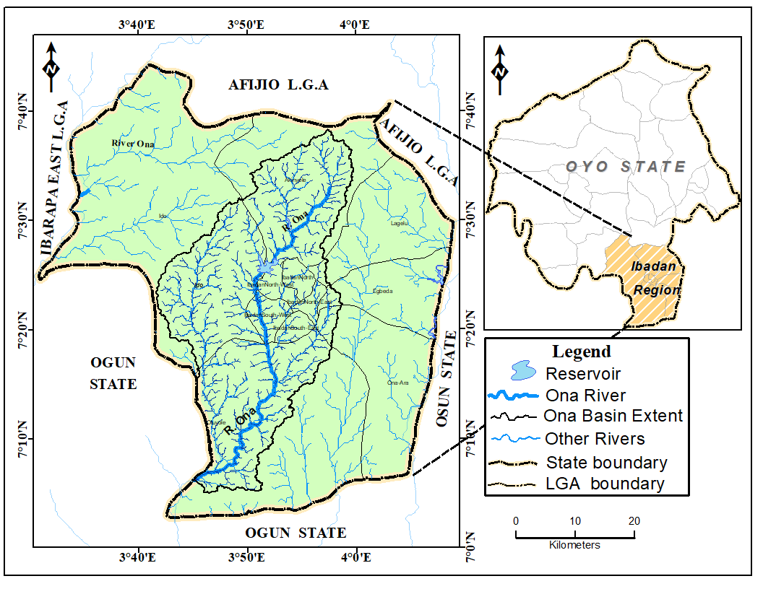

**Figure 1. The Study Area**

**MATERIALS AND METHODS**

This section describes the sources and methods of data collection, processing, analysis and presentation. The study explored the use of topographic maps, satellite imageries, Digital Elevation Model, and published journals for its successful implementation.

**GPS Points, Maps and Satellite Imageries**

Data set used in this study include: selected Rivers coordinates for stream mapping, boundary map of the study area, 12.5m Alos parsar Digital Elevation Model (DEM), topographic maps, Landsat imageries. This data set is summarized in Table below. Analysis of the dataset was carried out using ArcGIS 10.4 and ENVI 5.1 software.

**Table 1: Summary of Data Used**

|  |  |  |  |  |
| --- | --- | --- | --- | --- |
| No | Data | Resolution | Year | Source(s) |
| 1 | Topographical map sheet | 1:50,000 | 1995 | Office of the Surveyor General |
| 2 | ALOS PALSAR DEM | 12.5m | 2011 | Alaska Satellite Facility (www.asf.alaska.edu) |
| 3 | Landsat satellite imageries | 30m | 1984,2002 and 2018 | (<http://earthexplorer.usgs.gov>). |

**Radiometric Correction in Envi**

**Dark Object Subtraction (Correcting for Path Radiance)**

Incident irradiance (E), Terrain element of reflectance (P) in watts/m²

Outgoing radiance (L) = PET/2˄ where T = (Transmissivity of Atmosphere) watt/m²

Path radiance LP, is the light that never made it to the surface but scattered in the atmosphere some of which are scattered back to the sensor.

Measured radiance (L total) = PET/2˄+LP

So, L total = L+LP

L = L total – LP.

This technique finds the darkest pixels and subtract the value from all other pixels.

**Drainage Basin Delineation and Stream Ordering**

In order to delineate the Catchment boundary and drainage basin, the ALOS PALSAR Digital Elevation Model (DEM) covering the study area was imported into ArcGIS 10.4 for preprocessing, for the DEM to be used in drainage basin Delineation, it was projected to the UTM coordinate system to obtain the linear unit, the Arc Hydro Extension of the ArcGIS 10.4 was used to perform series of operations in order to extract the stream network as sub-basins as shown in Figure 3.1.

The fill sink was the first operation, it was applied to fill the imperfection in the digital elevation model, and subsequent layers such as flow direction, flow accumulation, stream definition, stream segments, catchment grid delineation, and catchment polygon were also created. Stream ordering was done using the stream order (According to strahler’s order) tool in the Hydrology tools in the ArcGIS Spatial analyst Arc tool box. The above process was performed in order to extract the drainage network and stream order of the study area.

Fill sinks

SRTM (DEM)

Flow direction

Flow Accumulation

Stream definition

Stream segmentation

Catchment Grid delineation

Catchment polygon processing

Stream ordering

**Figure 2.** Procedure for Drainage delineation and stream ordering.

**Calculation of Slope**

* Slope of the basin was calculated using ArcGIS raster calculator. The calculator builds and executes a single Map Algebra expression using Python syntax in a calculator-like interface. In this study it was used to calculate the slope of each stream order as recommended by literature (Leopold *et. al.,* and Tockner 2002).

**Table 2: Estimated riparian width in meters and slope in percent rise**

|  |  |  |
| --- | --- | --- |
| Stream order | Estimated riparian width (m) | Slope Class (%) |
| 1 | 30 | 0-10 |
| 2 | 60 | 11-45 |
| 3 | 90 | 45+ |
| 4 | 120 | 45+ |
| 5 | 150 | 45+ |

Source (Leopold *et. al.,* 1964, Tockner and Stanford 2002)

**RESULT AND DISCUSSION**

**ESTIMATION OF RIPARIAN ZONE**

The Arc Hydro extension tools in ArcGIS was used to calculate the drainage basin characteristics of Ona Basin within Ibadan Region. The results of the analysis revealed that Ona River has a dendritic drainage pattern. The analyses further showed that the 1st order has 4,150 streams, 2nd order has 67 streams, 3rd order has 15 streams, and 4th order has 2 streams while the 5th order has 1 stream. Basin slope was calculated, this was to enable the delineation of riparian zone. Slope Identifies the gradient, or rate of maximum change in steepness from each cell of a raster surface. The result revealed slope range of 6-76%. Areas with slope less than 10% made up about 24.7km² of the basin, area between slope ranges 10-15% made up about 29.05km² of the basin while areas with slope range of 15% and above made up about 47.0km² of the basin. These streams were buffered to a specific distance as cited by Leopold *et. al.,* 1964, the 1st order stream was buffered to a distance of 30m, 2nd order stream was buffered to a distance of 60m, 3rd order stream was buffered to a distance of 90m, 4th order was buffered to a distance of 120m and 5th order was buffered to a distance of 150m.

Given the degree of steepness the riparian zone of a stream order can be found, the raster calculator was used to calculate the areas that can be called the riparian zone, as shown on the (Figure) maps below, 1st order stream have riparian zone in areas where the slope is less than 15%, 2nd order streams have riparian zone where the slope is not more 45%, the third, fourth and fifth order stream can have riparian zone in areas where the riparian zone is more than 45%.

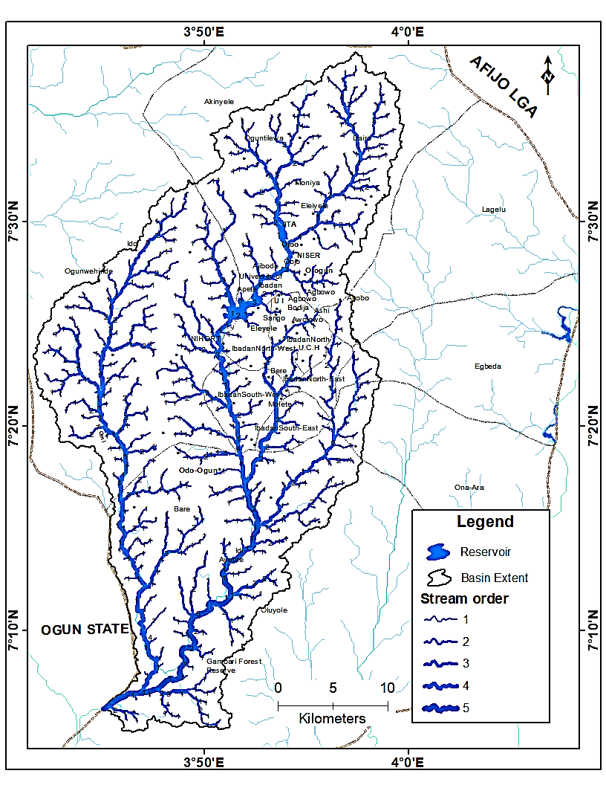

**Figure 3:** Map showing Stream order in the Ona drainage Basin in Ibadan.

The buffered streams were overlaid on the slope which was processed from the Alos parser DEM, areas that met the specific criteria were given the value of 1 by the raster calculator while areas that do not meet the criteria were given the value of 0. The select by attribute button in the layer’s attribute table was used to select the areas with the value of 1 as the riparian area. This was done for all stream order as shown on the (Fig 4.2) below.

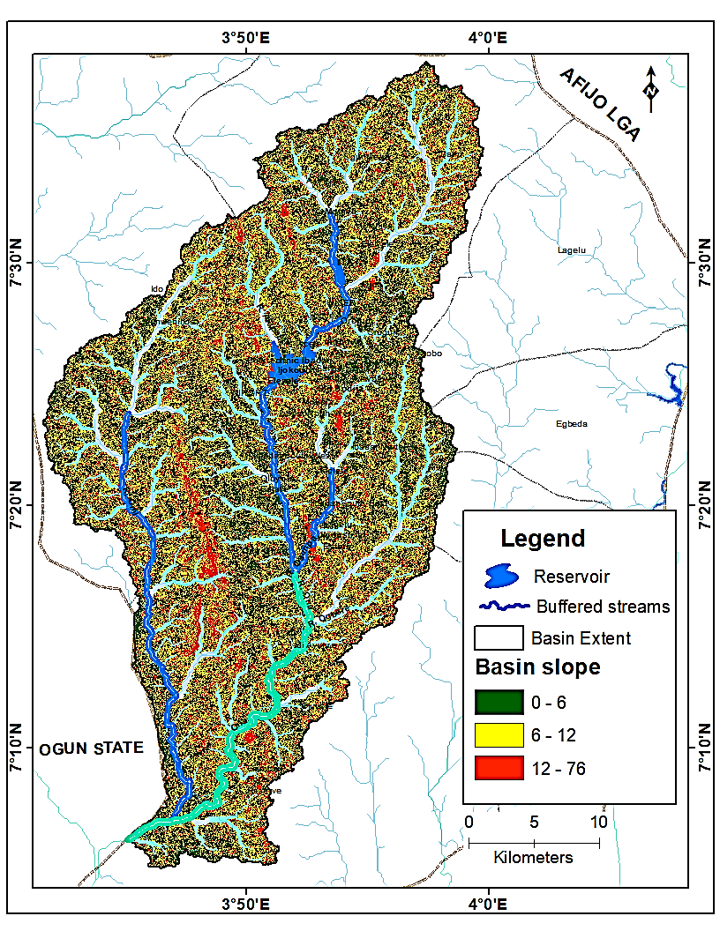

**Figure 4**: Map showing the slope of Ona drainage basin overlaid by buffered stream order.

The total riparian zone covered by the 1st stream order is 24.713km², the 2nd order streams covered about 29.05km² of riparian zone, the 3rd order steams has 16.978km² riparian zone, the 4th order streams has 20.14km² riparian zone while the 5th order stream has 9.93km² riparian zone. Fig 4.4 shows the extent of each stream order. The total area covered by riparian zone in the Ona drainage basin in Ibadan is estimated to be 100.81km².

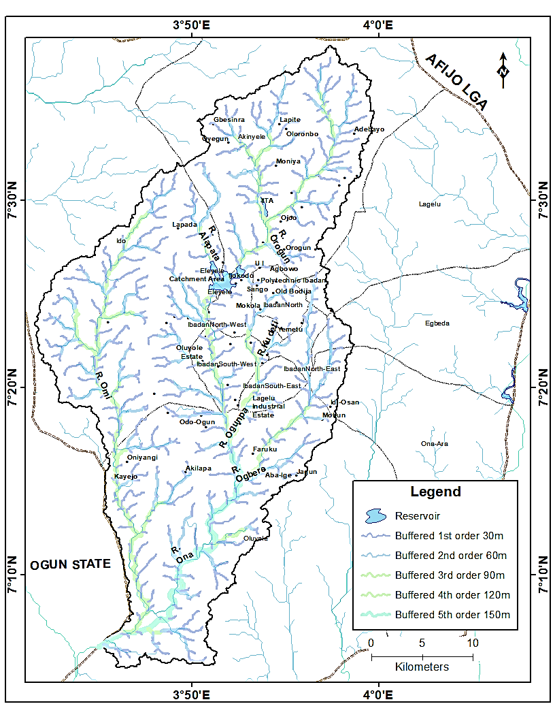

**Figure 5:** Map showing the Extent of riparian zone in Ona drainage basin.

**LANDCOVER OF RIPARIAN ZONE**

In order to examine the Land cover of the riparian zone the result from the analysis of extent of riparian zone was overlaid on the classified Landsat images (TM 1984, ETM+ 2002 and ETM+2018). The accuracy assessment of the 2018 land use/ land cover image was generated by comparing the classified image with reference data (ground truth point) which was done by generating random points on the classified image and exporting the points to google earth for ground truthing.

**Table 3: Confusion matrix for land use / land cover classes**

|  |  |  |  |  |  |  |  |
| --- | --- | --- | --- | --- | --- | --- | --- |
| Class Name | Built up | Light vegetation | Dense vegetation | Agricultural Land | Water body | Peri-Urban | Total |
| Built up | 4 | 0 | 0 | 0 | 0 | 0 | 4 |
| Light vegetation | 1 | 4 | 1 | 0 | 0 | 1 | 7 |
| Dense vegetation | 0 | 0 | 5 | 1 | 0 | 0 | 6 |
| Agricultural land | 0 | 0 | 0 | 5 | 0 | 0 | 5 |
| Water body | 0 | 0 | 0 | 0 | 6 | 0 | 6 |
| Peri-Urban | 1 | 1 | 0 | 0 | 0 | 6 | 6 |
| Total | 6 | 5 | 6 | 6 | 6 | 7 | 30 |
|  |  |  |  |  |  |  |  |

The overall accuracy for land use/land cover classification is 83%.

The images were clipped to the extent of the Ona drainage basin and according to stream order for the different years. In 1984, figure show that Agricultural activities and Peri-Urban growth were the main human activities that threatened the riparian zone with the highest value among the land use classes.

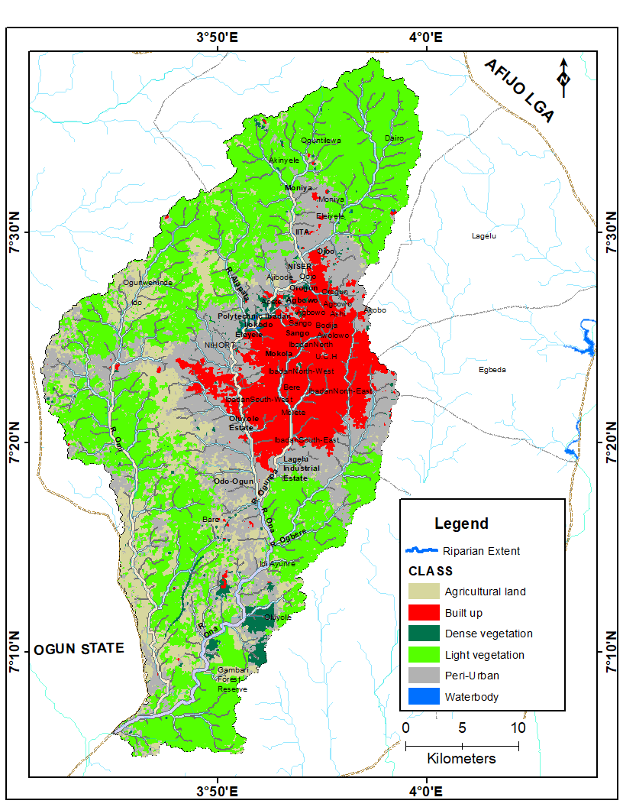

**Figure 6:** Land use /land cover of Ona drainage basin for 1984 overlaid with the buffered stream order.

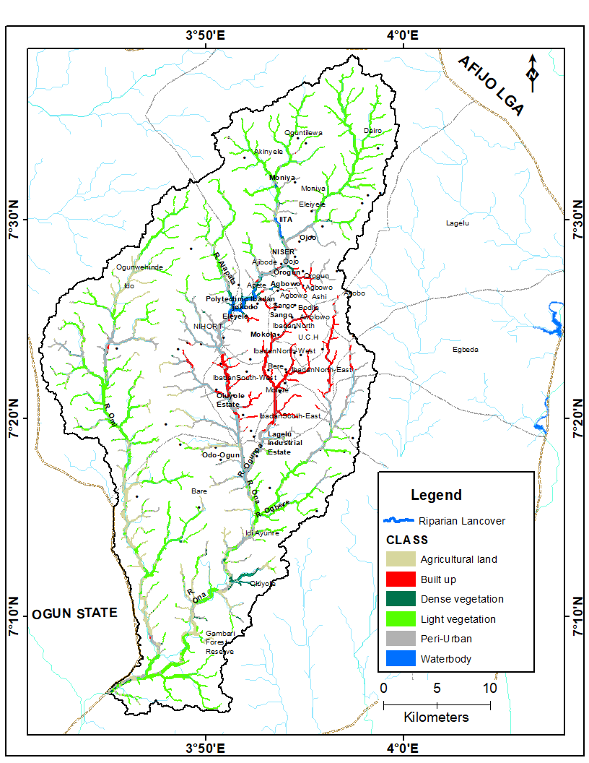

**Figure 7:** Map showing the land use /land cover within riparian zone of Ona drainage basin in 1984.

In 2002, Tables 4.3 (a, b, c, d, &e) show that more riparian zone has been converted to built up (Peri – Urban) and Agricultural land, this shows that riparian vegetation is constantly being removed for other land use, especially building of houses and farming, this was followed. This was affirm by the drastic reduction in the vegetation of the riparian zone within this period.

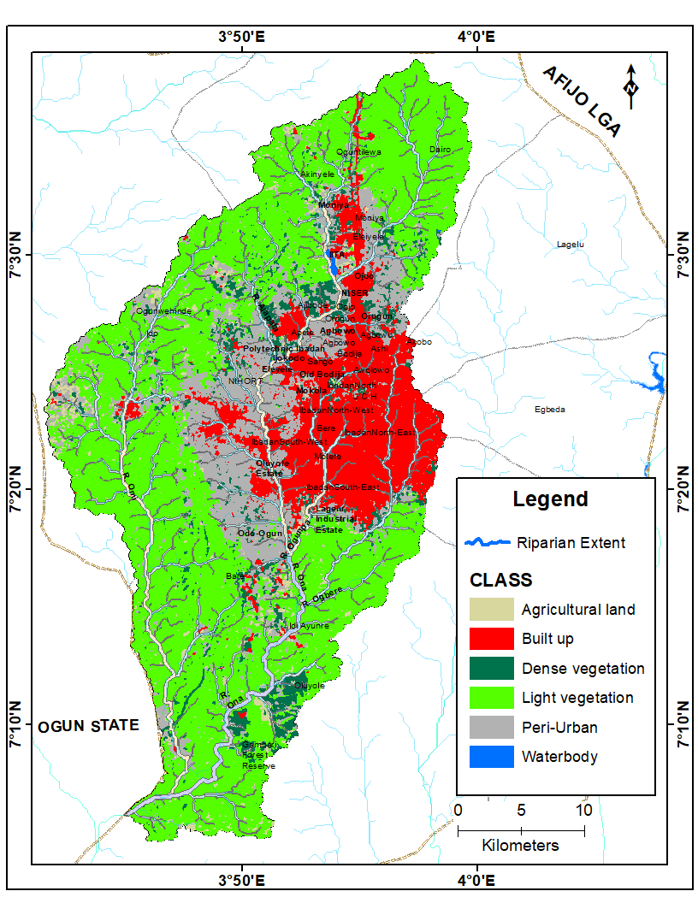

**Figure 8**: Land use /land cover of Ona drainage basin for 2002 overlaid with the buffered stream order.

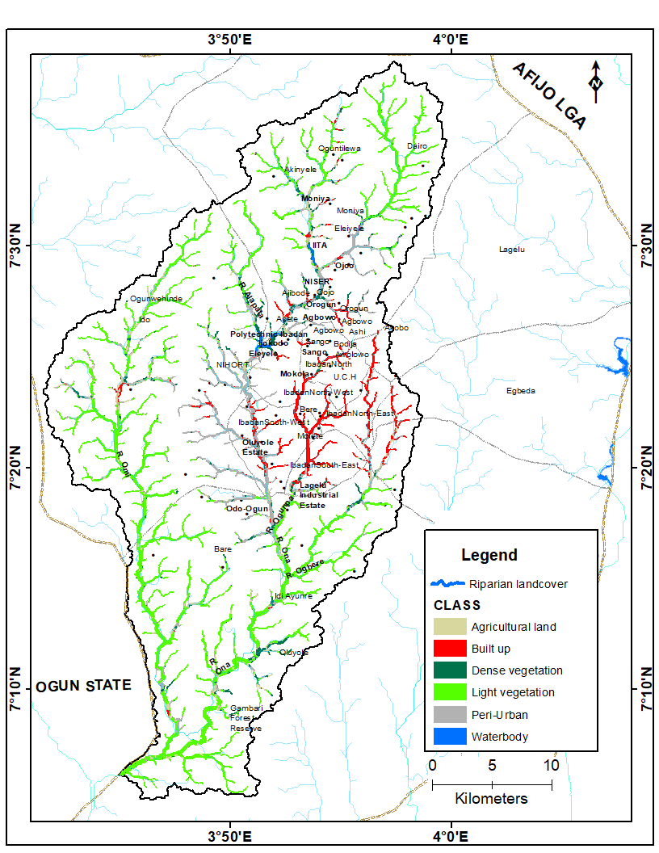

**Figure 9:** Map showing the land use /land cover within riparian zone of Ona drainage basin in 2002.

In 2018, figure show that the encroachment on riparian zone by human activities continued as Agricultural land, Peri-Urban and built up (Urban) had the highest percentage of the riparian zone. This shows that the riparian zone is in critical state with drastic reduction in vegetation over the past 16 years.

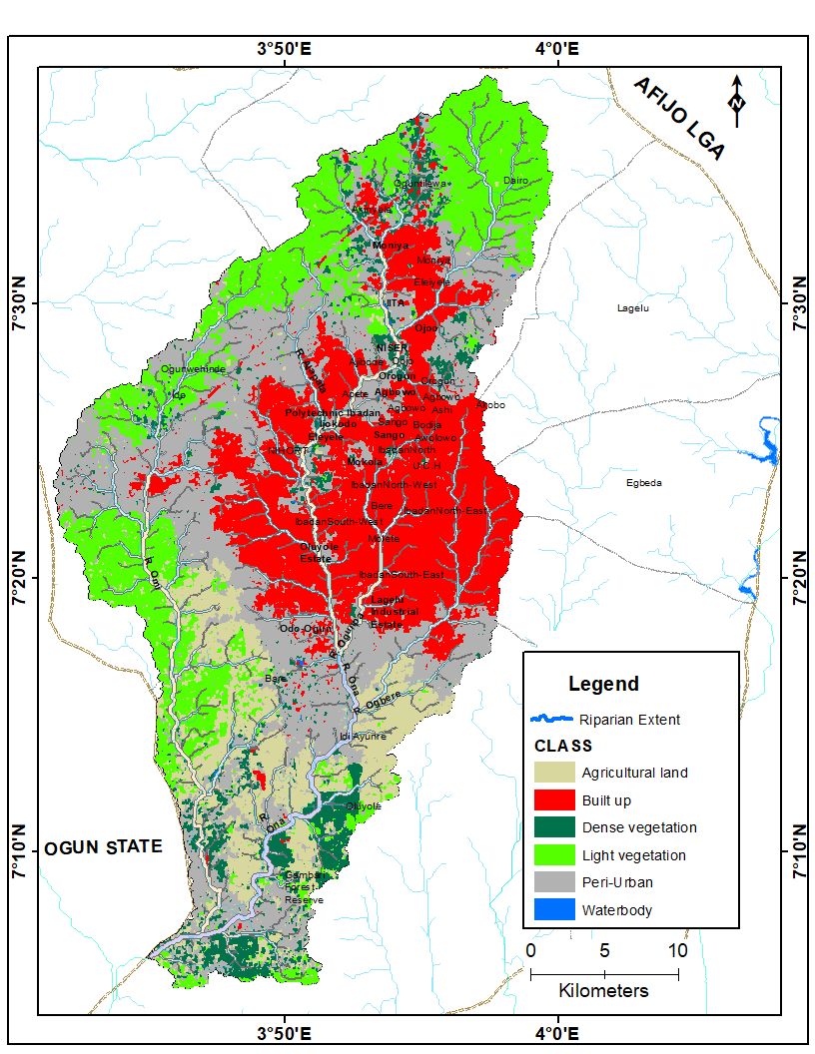

**Figure 10:** Map showing land use /land cover within riparian zone of Ona drainage basin in 2018.

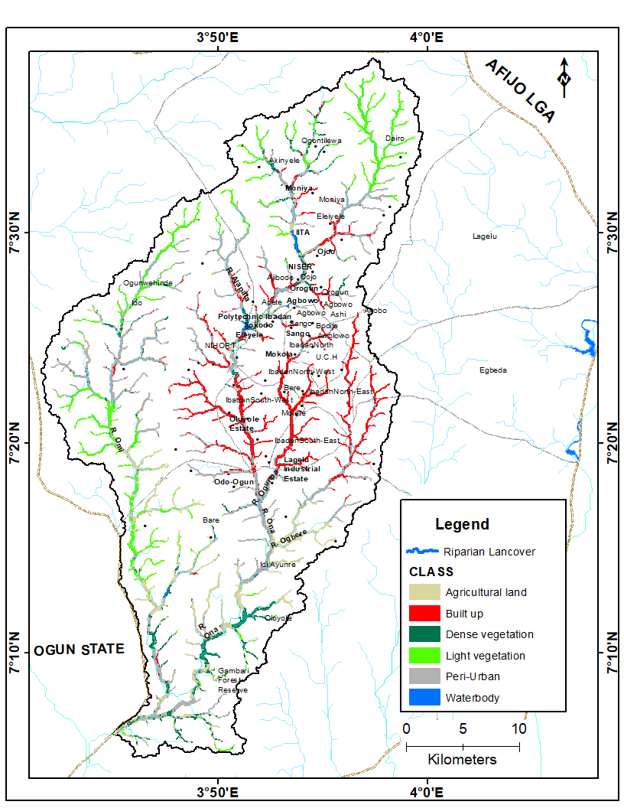

**Figure 11:** Map showing land use /land cover within riparian zone of Ona drainage basin in 2018.

**ANALYSIS OF SPATIAL AND TEMPORAL CHANGES IN LANDSCAPE OF RIPARIAN ZONE.**

To effectively analyze the spatial and temporal changes in the landscape of the riparian zone, the stream orders were merged together using the merge tool in ArcGIS data management toolbox. The 1st, 2nd, 3rd, 4th and 5th streams order were merged into one shapefile to give a total area covered by the riparian zone. This merged stream was overlaid on the result of the classified changed images of 1984 and 2002 and that of 2002 and 2018.

The results as presented by tables 4.4a & 4.4b indicated that more of riparian vegetation were lost to Agricultural land and Peri-urban with the former contributing to about 20% of the change, while the latter covered about 12% of the change in total riparian zone. This constitute the highest conversion rate between 1984 to 2002, it can then be said that farming was the human activities that contributed most to the changes in riparian zone between 1984 to 2002, followed by conversion from vegetation to bare surface, vegetated areas were converted to roads, concrete surfaces, excavated surfaces among others.

**Table:Land use/Land cover change in riparian zone 1984-2002**

|  |  |  |
| --- | --- | --- |
| Change between (1984-2002) | Area (sq.m) | Percentage (%) |
| Peri - Urban - Built up | 885056.84 | 0.9 |
| Peri - Urban - Dense vegetation | 1463241.28 | 1.5 |
| Peri - Urban – Agricultural land | 2681964.79 | 2.8 |
| Peri - Urban - Light vegetation | 49038.23 | 0.1 |
| Built up - Peri - Urban | 1743547.54 | 1.8 |
| Built up - Dense vegetation | 20100.11 | 0.0 |
| Dense vegetation - Peri - Urban | 1458635.74 | 1.5 |
| Dense vegetation - Built up | 149058.54 | 0.2 |
| Dense vegetation - Agricultural land | 321961.00 | 0.3 |
| Dense vegetation - Water body | 26111.83 | 0.0 |
| Agricultural land - Peri - Urban | 10026121.37 | 10.6 |
| Agricultural land - Built up | 33465.18 | 0.0 |
| Agricultural land - Dense vegetation | 1454773.35 | 1.5 |
| Agricultural land - Light vegetation | 76660.69 | 0.1 |
| Light vegetation - Bare surface | 11209394.24 | 11.8 |
| Light vegetation - Built up | 62207.85 | 0.1 |
| Light vegetation - Dense vegetation | 837444.28 | 0.9 |
| Light vegetation - Agricultural land | 19417758.12 | 20.5 |
| no change - no change | 42652586.16 | 45.0 |
| Water body Peri - Urban | 15461.10 | 0.0 |
| Water body - Dense vegetation | 83101.13 | 0.1 |
| Water body - Agricultural land | 140569.08 | 0.1 |
| Total | **94808258.45** | **100.0** |

**Table 4.5b: Land use/Land cover change in riparian zone 2002-2018**

|  |  |  |
| --- | --- | --- |
| Changes Between (2002-2018) | Area (sq. m) | Percentage (%) |
| Peri - Urban - Peri - Urban | 25104604.52 | 26.5 |
| Peri - Urban - Built up | 7366299.49 | 7.8 |
| Peri - Urban - Dense vegetation | 4745448.26 | 5.0 |
| Peri - Urban - Agricultural land | 3217793.69 | 3.4 |
| Peri - Urban - Light vegetation | 3273488.28 | 3.5 |
| Peri - Urban - Water body | 32284.87 | 0.0 |
| Built up - Peri - Urban | 243714.26 | 0.3 |
| Built up - Built up | 6720916.82 | 7.1 |
| Built up - Dense vegetation | 35748.06 | 0.0 |
| Built up - Water body | 14738.34 | 0.0 |
| Dense vegetation - Peri - Urban | 2014343.68 | 2.1 |
| Dense vegetation - Built up | 323540.24 | 0.3 |
| Dense vegetation - Dense vegetation | 2010576.07 | 2.1 |
| Dense vegetation - Agricultural land | 579173.23 | 0.6 |
| Dense vegetation - Light vegetation | 111334.33 | 0.1 |
| Dense vegetation - Water body | 77085.72 | 0.1 |
| Agricultural land - Peri - Urban | 9314910.18 | 9.8 |
| Agricultural land - Built up | 138826.31 | 0.1 |
| Agricultural land - Dense vegetation | 2218431.26 | 2.3 |
| Agricultural land - Farm land | 12238031.13 | 12.9 |
| Agricultural land - Light vegetation | 7583174.46 | 8.0 |
| Light vegetation - Peri - Urban | 862139.89 | 0.9 |
| Light vegetation - Dense vegetation | 142660.48 | 0.2 |
| Light vegetation - Agricultural land | 1571406.90 | 1.7 |
| Light vegetation - Light vegetation | 3867231.06 | 4.1 |
| Water body - Dense vegetation | 91717.79 | 0.1 |
| Water body - Agricultural land | 313537.63 | 0.3 |
| Water body - Light vegetation | 2700.00 | 0.0 |
| Water body - Water body | 592401.54 | 0.6 |
| Total | **94808258.50** | **100.0** |

**CONTRIBUTION OF SPECIFIC HUMAN ACTIVITIES TO CHANGES WITHIN THE RIPARIAN ZONE.**

Table 4.6 below gives a breakdown of the present state of the Ona Drainage Basin in Ibadan. The total area of the riparian zone was estimated to be 94808258.52 m² or 9.8 km² in 2018, Peri – Urban i.e. recent urban development occupies about 40% of the highest contributor to the changes within the zone, Agricultural land use follows with about 19% of the riparian zone used for different Agricultural purposes. The vegetation of the riparian zone which is one of it most important feature occupies about 15% of the zone, the same for built up, the forested or densely vegetated part of the zone has seriously been depleted by human activities, with only 10% of the zone still densely forested. The implication of this perpetual depletion and encroachment into the riparian zone will result in soil loss due to high surface run off of erosion, many part of the drainage basin will be susceptible to flooding due to the removal of the forested vegetation which is supposed to act as natural breaks for flood water during stream overflow. Detailed analysis of the land cover classes according to stream order is given below.

**Total Area Covered by Riparian Zone in 2018**

|  |  |  |
| --- | --- | --- |
| Class Name | Area (sq. m) | Percentage (%) |
| Peri - Urban | 37408359.25 | 39.5 |
| Built up | 14598716.64 | 15.4 |
| Dense vegetation | 9350151.52 | 9.9 |
| Agricultural land | 17890288.05 | 18.9 |
| Light vegetation | 14837410.55 | 15.6 |
| Water body | 723332.52 | 0.8 |
| Total | **94808258.52** | **100.0** |

Source: Author’s analysis, 2019

**4.6a First Order Riparian Land Cover in 2018**

|  |  |  |
| --- | --- | --- |
| Class Name | Area (sq. m) | Percentage (%) |
| Peri - Urban | 9602828.33 | 38.9 |
| Built up | 4120620.35 | 16.7 |
| Dense vegetation | 1968881.13 | 8.0 |
| Agricultural land | 3732184.05 | 15.1 |
| Light vegetation | 5247317.07 | 21.3 |
| Total | 24671830.93 | 100.0 |

Source: Author’s analysis, 2019

**4.6b** **Second Order Riparian Land Cover in 2018**

|  |  |  |
| --- | --- | --- |
| Class Name | Area (sq. m) | Percentage (%) |
| Peri - Urban | 10657898.07 | 36.8 |
| Built up | 5571366.94 | 19.2 |
| Dense vegetation | 2002776.49 | 6.9 |
| Agricultural land | 5488754.12 | 19.0 |
| Light vegetation | 5233735.02 | 18.1 |
| Total | **28954530.63** | **100.0** |

Source: Author’s analysis, 2019

**4.6c Third Order Riparian Land Cover in 2018**

|  |  |  |
| --- | --- | --- |
| Class Name | Area (sq. m) | Percentage (%) |
| Peri - Urban | 7134553.54 | 42.6 |
| Built up | 2174567.18 | 13.0 |
| Dense vegetation | 1609811.36 | 9.6 |
| Agricultural land | 2725434.44 | 16.3 |
| Light vegetation | 3113233.67 | 18.6 |
| Total | **16757600.19** | **100.0** |

**4.6d Fourth order riparian land cover in 2018**

|  |  |  |
| --- | --- | --- |
| Class Name | Area (sq m) | Percentage (%) |
| Peri - Urban | 8489173.49 | 43.2 |
| Built up | 3330261.26 | 16.9 |
| Dense vegetation | 1556581.62 | 7.9 |
| Agricultural land | 4292836.01 | 21.8 |
| Light vegetation | 1984347.18 | 10.1 |
| Total | **19653199.55** | **100.0** |

Source: Author’s analysis, 2019

**4.6e** **fifth order riparian land cover in 2018**

|  |  |  |
| --- | --- | --- |
| Class Name | Area (sq. m) | Percentage (%) |
| Peri - Urban | 4046398.08 | 40.7 |
| Built up | 22627.31 | 0.2 |
| Dense vegetation | 2851759.33 | 28.7 |
| Agricultural land | 2898005.07 | 29.2 |
| Light vegetation | 113708.77 | 1.1 |
| Total | **9932498.57** | **100.0** |

Source: Author’s analysis, 2019.

**CONCLUSION**

This study has examined the impact of Human activities on the Ona river drainage basin and found out that indeed human activities is the highest contributor to the changes that have taken place in the riparian zone in 34 years, of all the human activities examined to cause changes in the riparian zone, Urban development as occasioned by the growth of the Ibadan city and various Agricultural land use like uncontrolled farming were the largest contributors to the changes that occur in the riparian zone. This findings goes a long way to indicate that the level of awareness of both the citizenry and the policy makers on the ecosystem services the riparian zone provides is extremely low, as these results have shown that the riparian zone is use for farming all year round as no conservation practice has been implemented by the government and the decision makers to preserve this sensitive ecosystem region. The changes that was observed from 2002 to 2018 indicated that built up is fast encroaching into the riparian zone of the Ona drainage basin in Ibadan and it must be checked on time to avert serious environment hazard this might cause.

The study has also shown that GIS is an effective tool in mapping the riparian ecosystem extent for protection and conservation practice.

To obtain the many benefits that a riparian corridor can provide, certain minimum principles must be adhered to: as cited by (Hausner *et. al*., 2018)

• Riparian corridors should extend at least 75 feet from the edge of the stream to perform properly. The 75 feet should include several distinct zones that perform specific functions. Ideally, the first zone should consist of undisturbed forest to provide food and shade for the stream. The second zone should consist of managed grasses and forest that allows for infiltration of runoff, filtration of sediment and nutrients, and nutrient uptake by plants. Finally, flow into the buffer should be transformed from concentrated flow into sheet flow to maximize ground contact with the runoff.

• Development within the riparian corridor should be limited only to structural facilities that are necessary for public health and safety. Agricultural activities would be permitted within the outer zone of the riparian corridor provided they were conducted in conformance with recognized soil conservation practices. When construction activities occur within the riparian corridor, such as stream crossings, specific mitigation measures should be taken.

• The riparian corridor should be uninterrupted. This will help reduce concentrated flow from entering the stream and “shortcircuiting” the filtration and infiltration benefits of riparian corridors. Uninterrupted corridors also provide continuous habitat for the passage of wildlife.

• Recreation within the riparian corridor should be balanced with the effect it may have upon existing features. For example, physical invasion of a riparian corridor maybe limited when it contains plant or animal species of concern or steep slopes or significantly impacts adjacent landowners.

**RECOMMENDATIONS**

Based on the findings of this study, it is therefore recommended that:

* In order to reap the benefit of riparian zone, it is essential to retain the zone in a vegetated state, preferably as forests. The GIS technique used in this study have proved to be effective and efficient to map accurately the areas that will be retained. This can be used by the decision makers to obtain similar result for riparian zone protection and conservation in the Ona river drainage basin.

The GIS techniques and analysis used in this study also gives an overview of changes in the riparian zone as mostly occasioned by human activities, this will give the decision makers an idea of what activity to control to easily start the restoration and preservation of the riparian zone ecosystems in the Ona River’s drainage basin.

**References**

Aquifers, S., & Amanambu, A. C. (2016). *Geogenic Contamination : Hydrogeochemical processes and relationships in Geogenic Contamination : Hydrogeochemical processes and relationships in Shallow Aquifers of Ibadan , South-West Nigeria*. (December 2015). https://doi.org/10.1515/bgeo-2015-0011

Apan, A. A., Raine, S. R., & Paterson, M. S. (2002). *Mapping And Analysis of Changes in the Riparian Landscape Structure of the Mapping and Analysis of Changes in the Riparian Landscape Structure of the Lockyer Valley Catchment , Queensland , Australia*. *2046*(March). https://doi.org/10.1016/S0169-2046(01)00246-8.

Chambers, J.C. & Miller, J.R. (Eds). (2004*). Great basin riparian ecosystem, ecology, management and restoration*. Washington D.C: Society for ecological restoration international.

Daniel Arizpe, Ana Mendes, and João. E. Rabaça 2008. *SUSTAINABLE RIPARIAN ZONES A Management Guide Edited.*

Egbinola,Amanambu,&Taiwo 2016. *Impact of Farming on Riparian Vegetation Along Ona*

*and Orogun Rivers, Ibadan , Oyo State , Nigeria Impacto da Agricultura na Vegetação Ciliar dos Rios Ona e Orogun em Ibadan , Estado de Oyo ( Nigéria )*. (August 2015).

Emre Akturk (2013). *RAPID RIPARIAN BUFFER WIDTH AND QUALITY ANALYSIS USING LIDAR IN* SOUTH CAROLINA.

FORMECU 1998: *The assessment of vegetation and land-use changes in Nigeria between*

1976/78 and 1993/95.

Goetz, S. J. (2006). *REMOTE SENSING OF RIPARIAN BUFFERS : PAST PROGRESS AND*

*FUTURE PROSPECTS 1*. *0296*(04205), 133–143.

Gregory, S. V, Swanson, F. J., Mckee, W. A., Kenneth, W., Gregory, S. V, Swanson, F. J.Cummins, K. W. (2019). *An Ecosystem Perspective of Riparian Zones Focus on links between land and water*. *41*(8), 540–551.

Hausner, M. B., Huntington, J. L., Nash, C., Morton, C., McEvoy, D. J., Pilliod, D. S., … Grant, G. (2018). Assessing the effectiveness of riparian restoration projects using Landsat and precipitation data from the cloud-computing application ClimateEngine.org. *Ecological Engineering*, *120*(February), 432–440. https://doi.org/10.1016/j.ecoleng.2018.06.024.

Hyatt, T.L., T.Z. Waldo, and T.J. Beechie. 2004. *A watershed scale assessment of riparian forests, with implications for restoration. Restoration Ecology 12(2):175-183.*

Ilhardt, B. L., E. S. Verry, and B. J. Palik. 2000. *Defining riparian areas. Pg. 29.*

Johansen, K., Coops, N. C., Gergel, S. E., & Stange, Y. (2007). *Application of high spatial resolution satellite imagery for riparian and forest ecosystem classification*. *110*, 29–44. https://doi.org/10.1016/j.rse.2007.02.014.

Jontos, R., 2004. Vegetative buffers for water quality protection*: An introduction and guidance Document. Connecticut Association of Wetland Scientists White Paper on Vegetative Buffers.* Draft version 1.0.22.

Klemas, V., 2014. Remote sensing of riparian and wetland buffers: *An overview. Journal of*

*Coastal Research* 30, 869-880.

Karen, M.M. & Karen, A.S. (1998). *Riparian ecosystem creation and restoration: Functions,*

*fish and wildlife habitat.* U.S Fish and Wildlife Service Biological Report, 89(20), 1–59.

Lawal, M. S. (2016). *Threatened Riparian Habitats in Selected River Banks in Ogun State,*

*Nigeria*. (April). <https://doi.org/10.13140/RG.2.1.3589.9283>.

Leopold L.B, Wolman M.G Miller JP. 1964. *Fluvial Process in Geomorphology. Dover*

*publisher, New York.*

Miller, J.R., T.T. Schulz, N.T. Hobbs, K.R. Wilson, D.L. Schrupp, and W.L. Baker. 1995.

*Changes in the landscape structure of a southeastern Wyoming riparian zone following shifts in stream dynamics. Biological Conservation* (72)371-379.

Naiman, R.J., Decamps, H. & McClain, M.E. (2005). *Riparian ecology, conservation, and*

*management of streamside communities*. Amsterdam: Elsevier Academic Press

National Research Council (NRC). 1995. *Wetlands: characteristics and boundaries.*

*Washington, DC: National Academy Press.*

National Research Council, U.S. (2002). *Riparian areas, functions and strategies for*

*management.* Washington D.C.: The National Academies Press.

Narumalani, S., Y. Zhou, and J.R. Jensen. 1997. *Application of remote sensing and geographic Information systems to the delineation and analysis of riparian buffer zones. Aquatic Botany* 58:393-409.

Odadal, O.E., Olago, D.O., Bugenyi, F., Kulindwa, K., Karimumuryango, J., West, K., Ntiba, M., Wandiga, S., Aloo-Obudho, P. & Achola, P. (2003*). Environmental assessment of the east* *African rift valley lakes, Overview article. Aquatic Science, 65*, 254–271.

Orewole, M. O., Alaigba, D. B., & Oviasu, O. U. (n.d.). *Riparian Corridors Encroachment and Flood Risk Assessment in Ile-Ife : A GIS Perspective*. 1–16.

*The national academies press*. Riparian Areas (2002): *Functions and Strategies for Management*. https://doi.org/10.17226/10327.

United States Agency for International Development (USAID). (2008). *Sustainable livelihoodsand water management in shared river basins: Lower Songkram Basin, Thailand*. CaseStudy. From http://www.usaid.gov/locations/asia/countries/rdma/.

Watson, A.J. & Basher, L.R. (2006). Stream bank erosion: *A review of processes of bank failure measurement and assessment techniques and modelling approaches*. Montueka Integrated Catchment Management Programme. Land Care ICM Report No. 2006-2006/01, 32.